Assignment #5: Image Segmentation using K-Means

**Course Instructor:** Dr. Shahnawaz Qureshi  
**Course:** Artificial Intelligence

**Due:** 29th November 2023, Wednesday 11:59 p.m.

**Instructions:**

* You are allowed to discuss this assignment verbally but a plagiarism check will be maintained.
* If there are any assignment related queries, you can e-mail one of the TA’s.
* Submit your file under the naming **convention iXXXXXX_Section.ipynb (E.g. i210328_A.ipynb).**
* Do not zip your files. A 5% penalty will be applied :(.
* Submit the assignment on time.
* Late submissions will receive a 10% penalty.
* Assignment will be due by **29th November 2023, Wednesday 11:59 p.m.**
* Deadline will not be extended.
* Lastly, have fun :). The goal with this assignment to make you realise how you can use simple algorithms like K-Means which act as the first step into solving some advanced problems like Object Detection in Images.

# Assignment #5: Image Segmentation using K-Means

**Introduction:** Image segmentation is the process of partitioning a digital image into multiple image segments, also known as image regions or image objects. There are various types of image segmentation techniques but for the focus of this assignment, you’ll only be working on colour-based segmentation. An example is shown below:

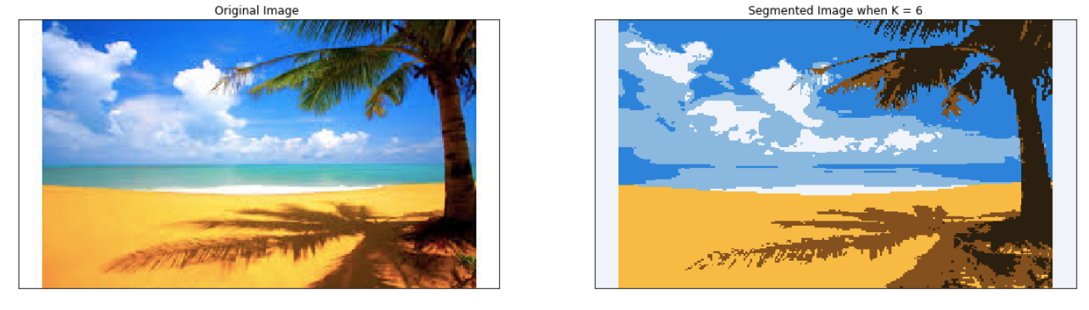

We generally do image segmentation to reduce the complexity of the image and allow the image to be used in various tasks, such as Object Detection later on.

Let’s take an example, the image below has 3 distinct colours. Therefore, it’s reasonable to infer that this image can be clustered into 3 different groups.

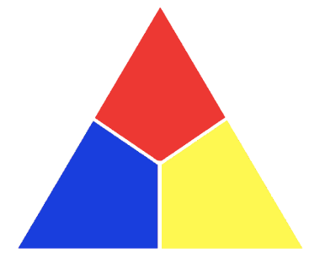

But when you dealt with images in your previous assignments, you noticed that all of the image’s pixels are displayed in 3 channels of NxN matrices, where each channel would represent the pixel’s colour (technically its intensity) in the red, green or blue region.

Assuming our X, Y and Z axis to be the Red, Green and Blue channels, we can plot all the pixels of the above image in a 3D space. Here’s what it would look like:

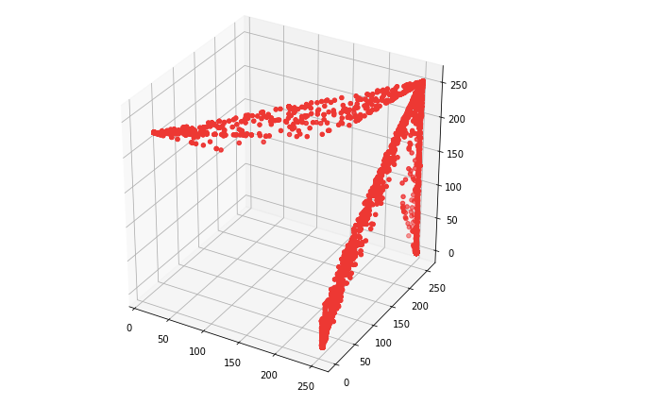

We can see that this image can indeed be clustered into 3 groups but how would you use K-Means to cluster it?

Assuming a K value of 3, you can classify each pixel into one of the 3 distinct groups but there’s a catch. Since each pixel exists in a 3D space of Red/Green/Blue channel, your mean pixel for each cluster would also need to be in a 3D space (e.g ClusterA would have the mean pixel as [59, 110, 60] and ClusterB would have the mean pixel as [120, 50, 90] etc.).

As such, you need to create the 3 clusters and place the pixel value in whichever cluster it is closest to, keep repeating the K-Means algorithm until a certain number of steps or there is no change between the new clusters and the old clusters.

At the end, you will have 3 clusters with different mean pixel values. The data inside the clusters would be irrelevant now since the algorithm is done training. The important information you will need to keep are the mean pixel values for each cluster.

Now, you will need to pass your image again and this time, compare each pixel’s value with all of the mean pixel values. Whichever one the pixel is closest to, replace the pixel’s value with that cluster’s mean pixel value. As such, you’re basically replacing each pixel of the image with its closest cluster’s mean pixel value.

Finally, you will have a segmented image which you can display using matplotlib :).

## Assignment:

**Q1)** Do color-based image segmentation on any singular image you like using a K-Means algorithm you have created **from scratch**. Assume a K value of 3.

**Q2)** Plot this image using matplotlib

**Q3)** Identify a better K value for the image you have chosen. Write it down and run the algorithm again using your new K value. Plot the newly segmented image using matplotlib and describe if the results were better than the previous segmented image.

**Rubric:**

|  |  |
| --- | --- |
| Category | Marks |
| Question 1 | **60** |
| Question 2 | **20** |
| Question 3 | **10 + 10** |

Total: 100 marks